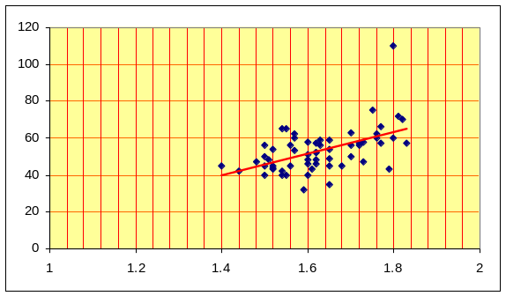
No correlation

Difficult to draw a line of best fit.
Some negative correlation

There are three points that are a little further away from the line of best fit and are possible outliers.

A reasonably obvious relationship exists

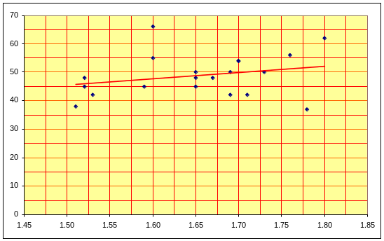
Weak positive correlation

There is at least one point that is a greater distance from the line of best fit than the others – possible outliers.

A vague relationship exists

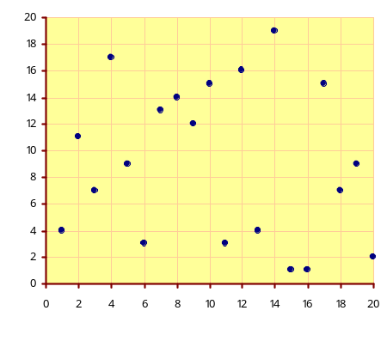
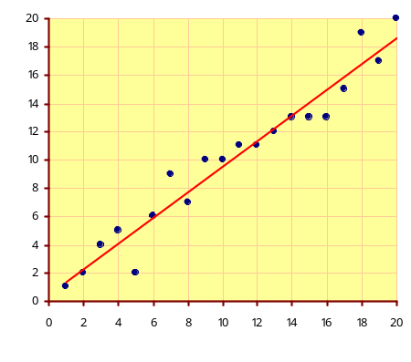
Some positive correlation

There is one point that is a much greater distance from the line of best fit than the others – an obvious outlier.

Sample size is large enough to make conclusions meaningful
Strong positive correlation

All points are very close to a straight line of best fit.

Very meaningful predictions can be made using the data

